**INFO 2302 Web Technologies**

Young Tech

Hotel Soul of D ‘ Relax Resort

**Group Young Tech**

|  |  |
| --- | --- |
| Adzreen Nulsyazwan Bin S.Nadzeer | 1817873 |
| Muhammad Amirul Aiman Bin Yusoff | 1826557 |
| Ahmad Irfaan Helmi Bin Jaffar | 1828459 |
| Muhammad Aidil Fahmiey Bin Osman | 1819369 |
| Muhammad Afiq Bin Munir | 1818931 |
|  |  |

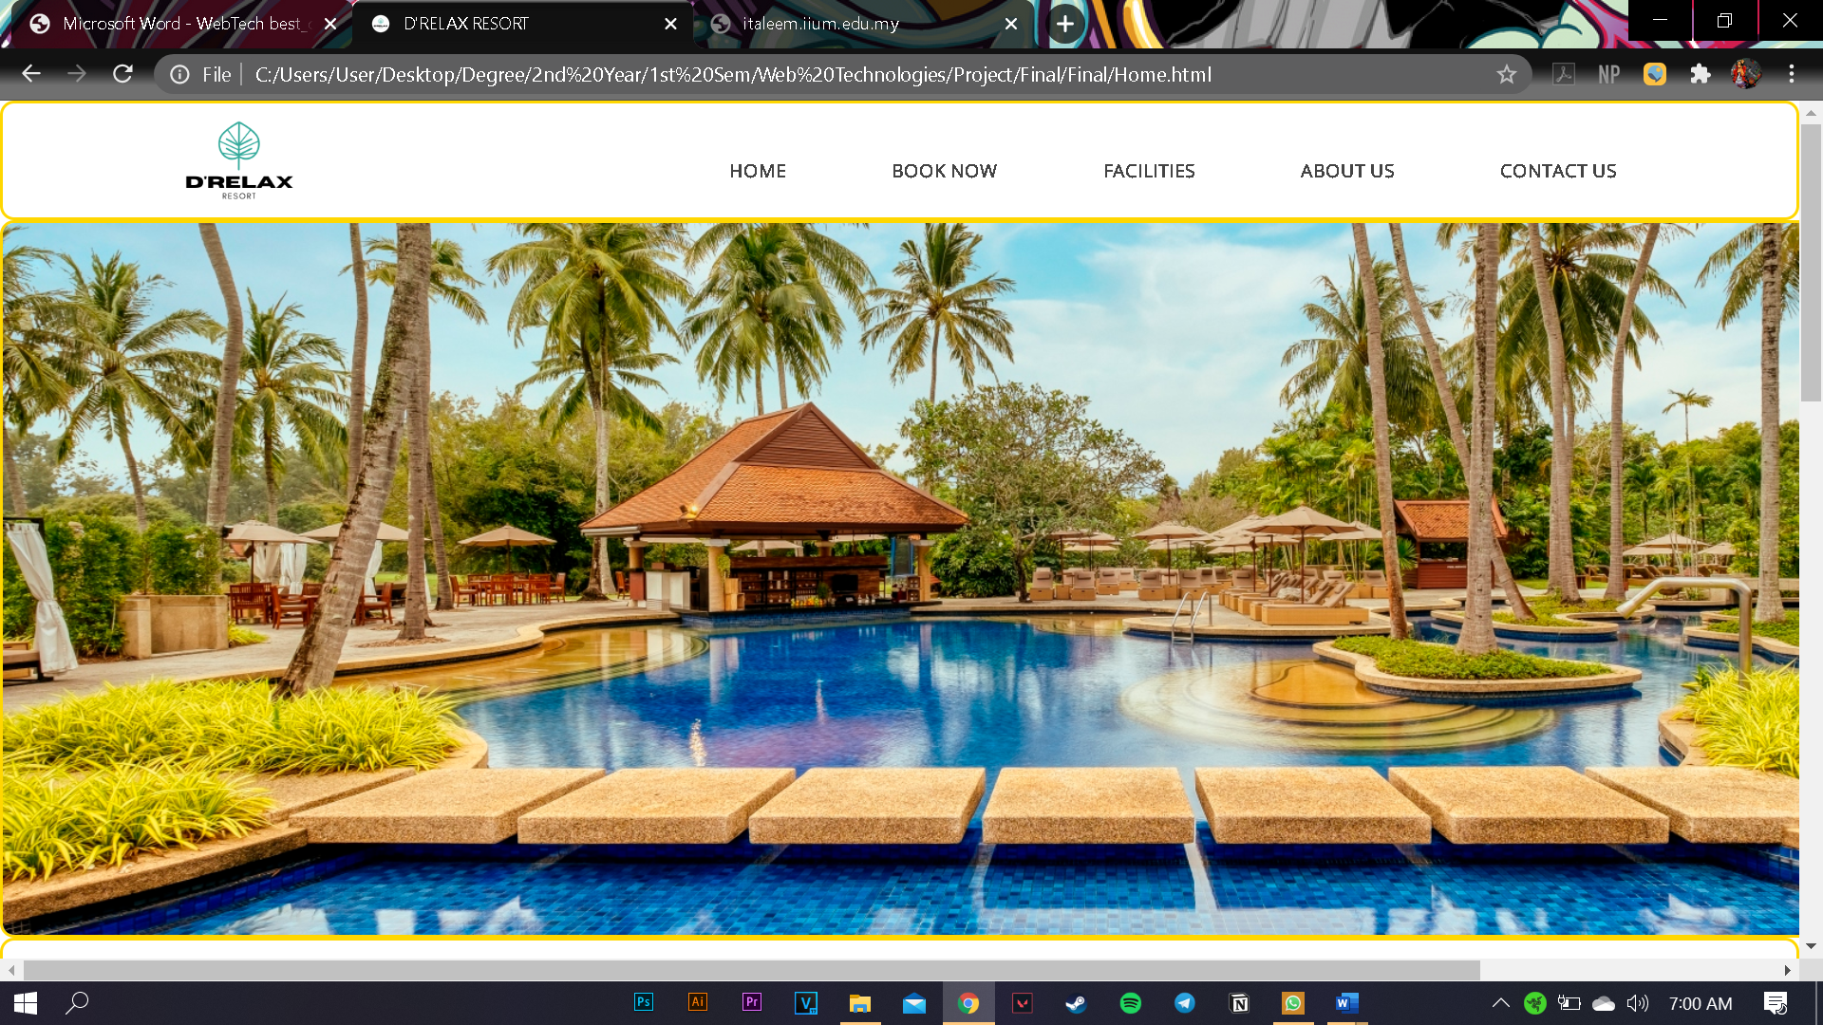

Figure 1 Homepage Part 1

* The homepage contain appropriate, high quality images for the customers view

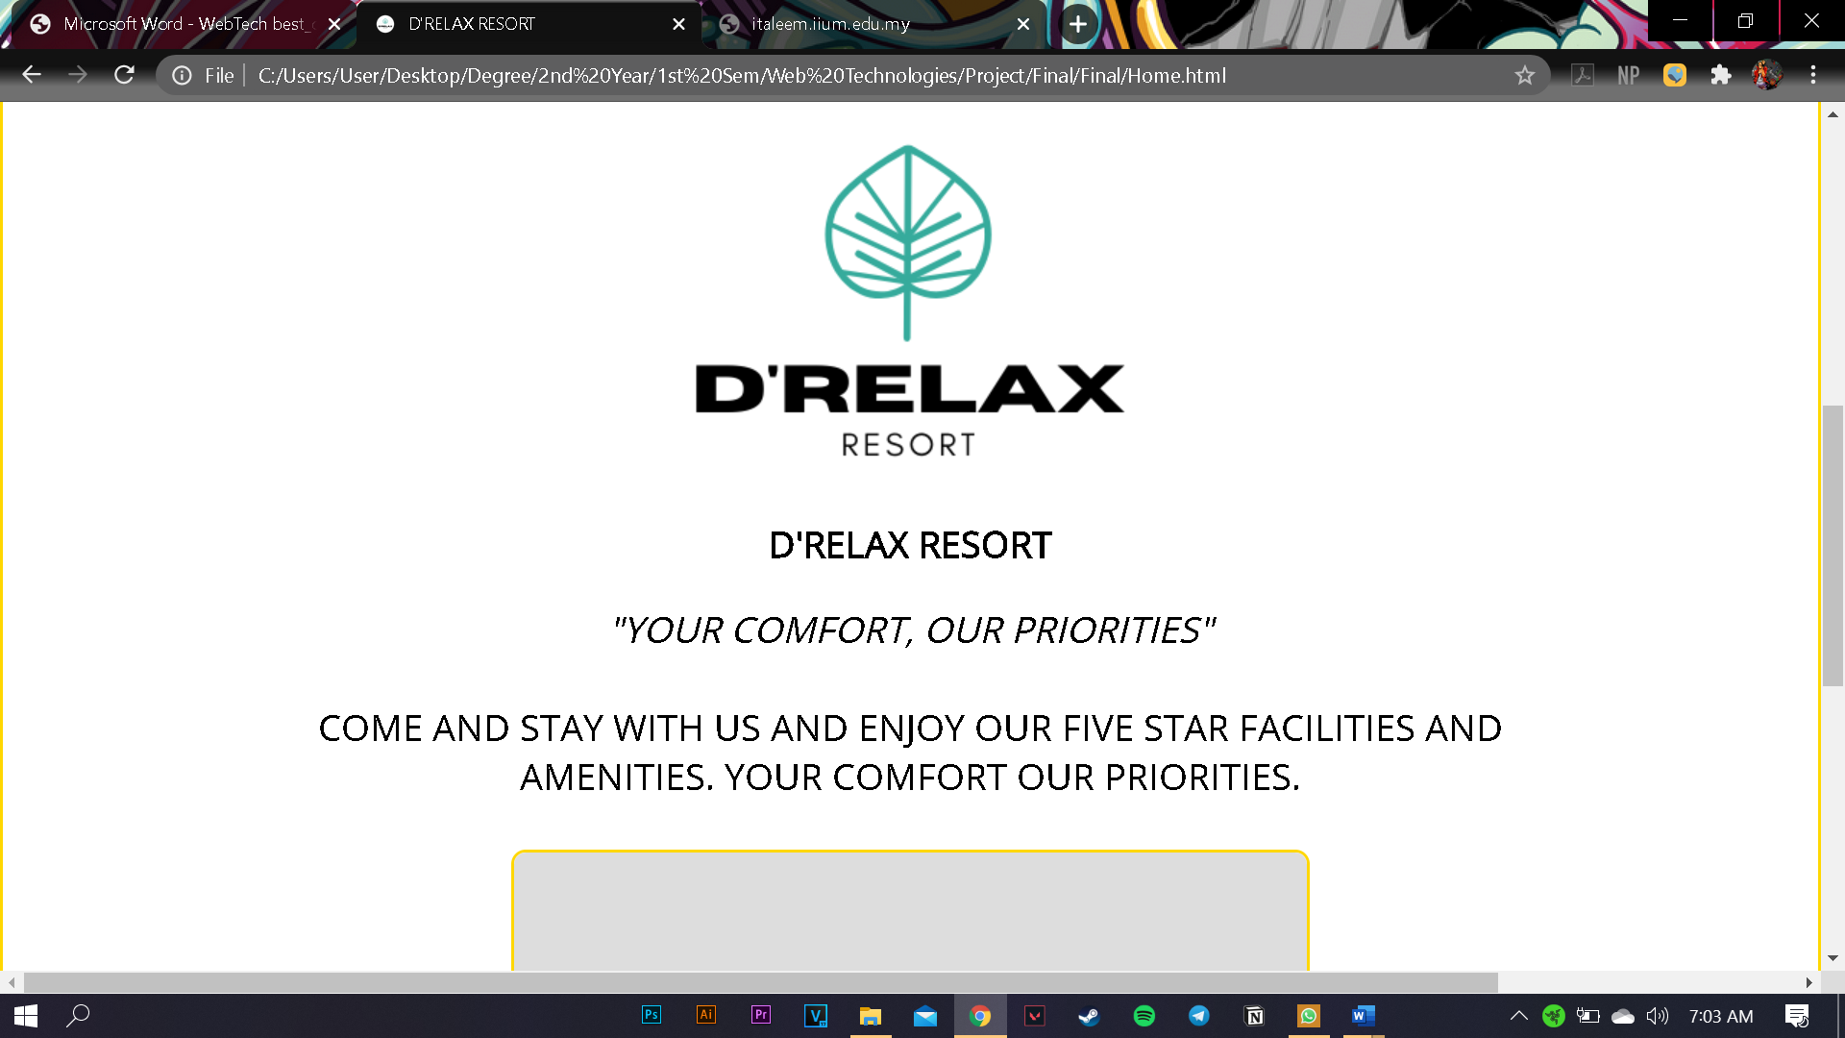

Figure 2 Homepage Part 2

* Information are hidden in the css
* Footer contain address and icon that link with our social profile.

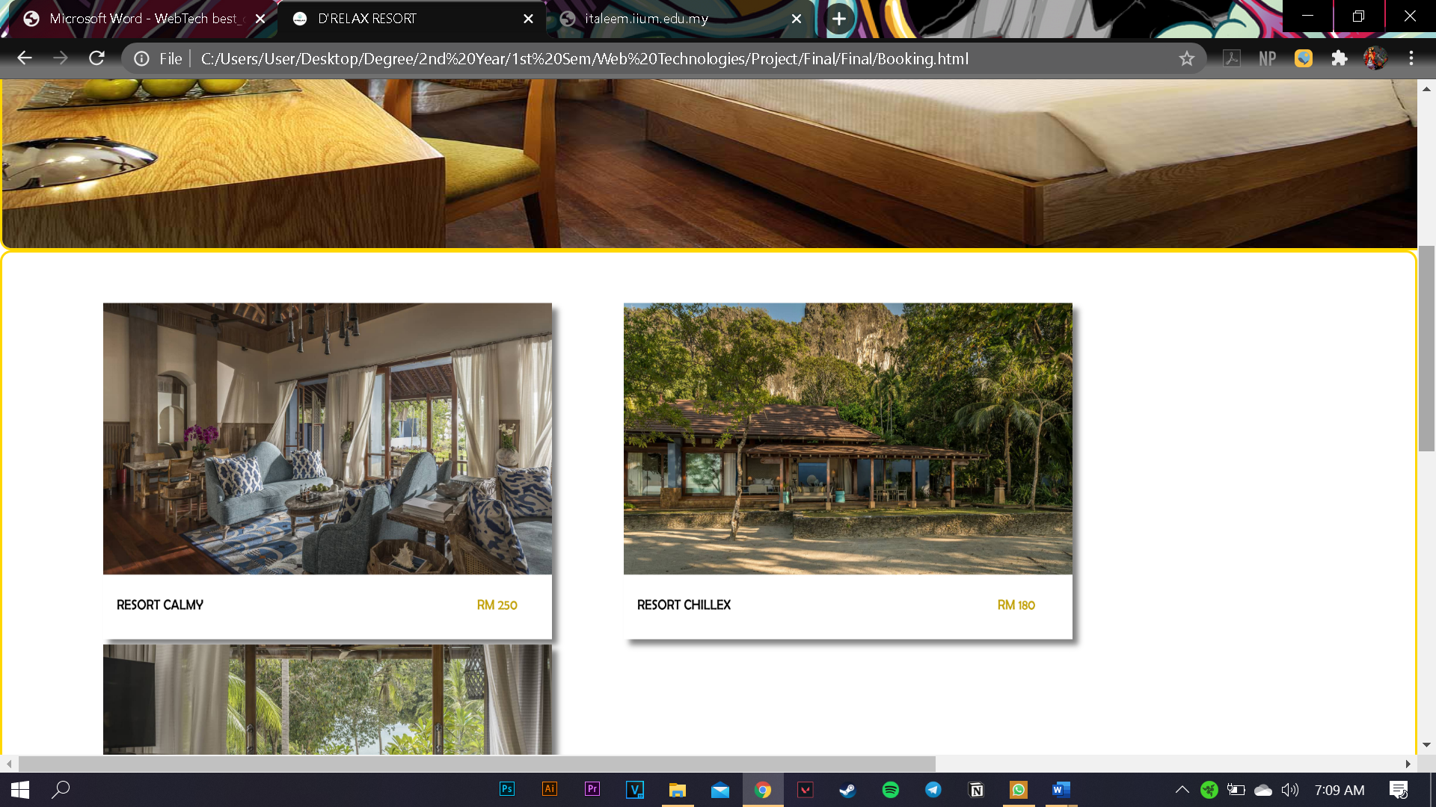

Figure 3 Book Now page

* Variety of room pictures for customers view.
* Pictures are arrange in css.

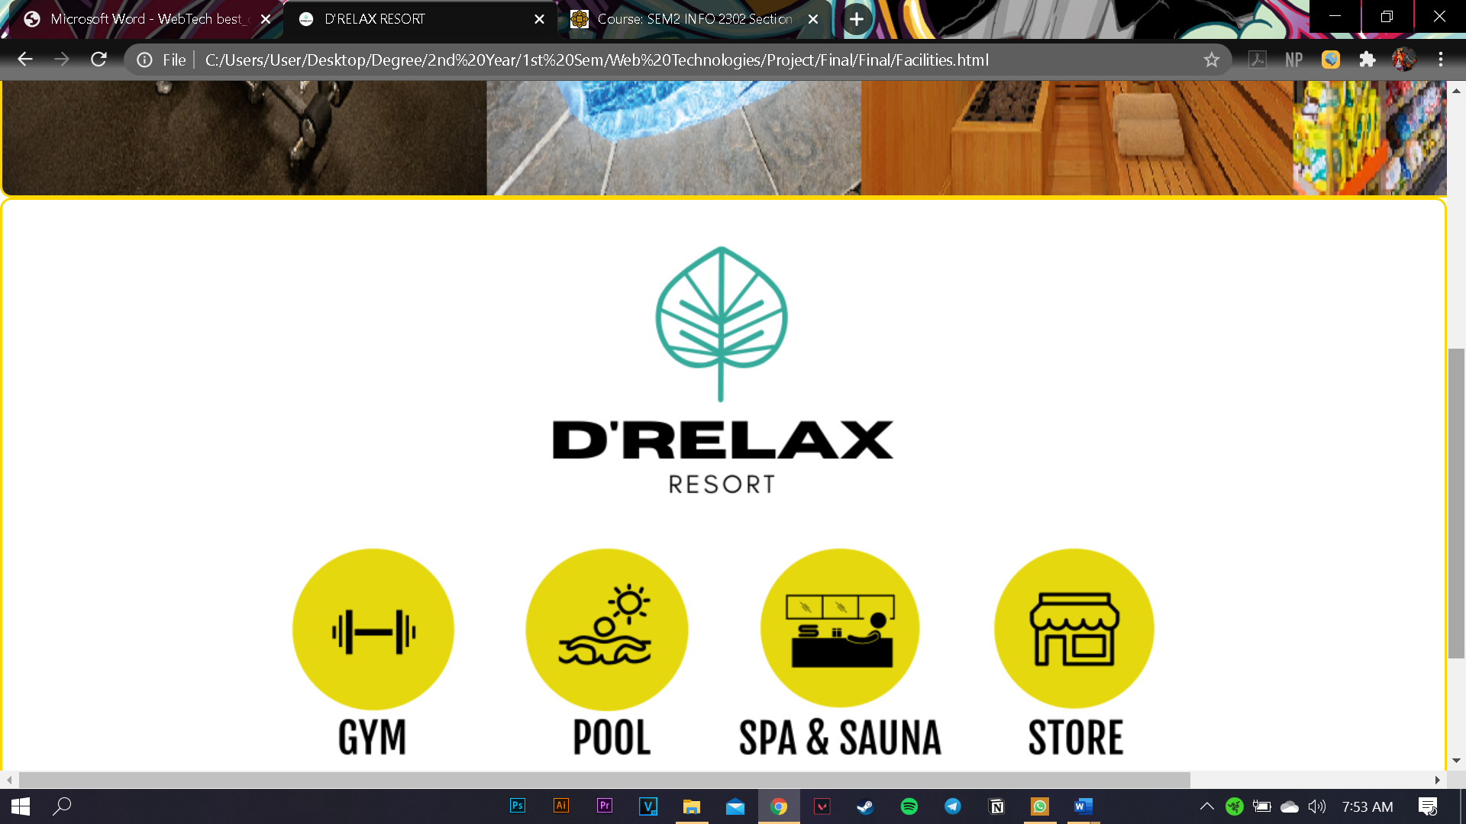

Figure 4 Facilities Page

* Navigation icon that link with other facilities page

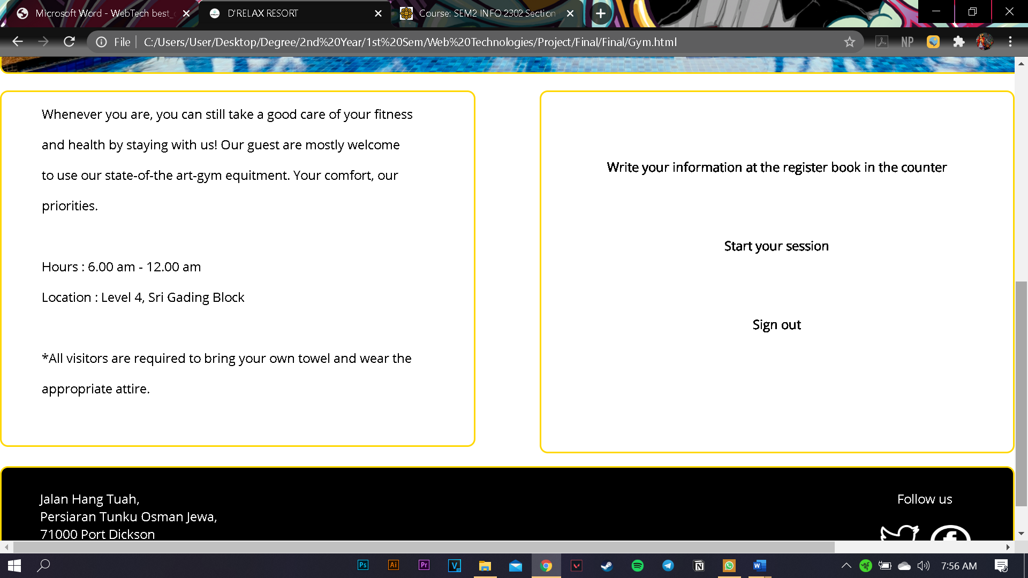

Figure 5 Gym Page

* Text are arrange in systematic order for the customer view

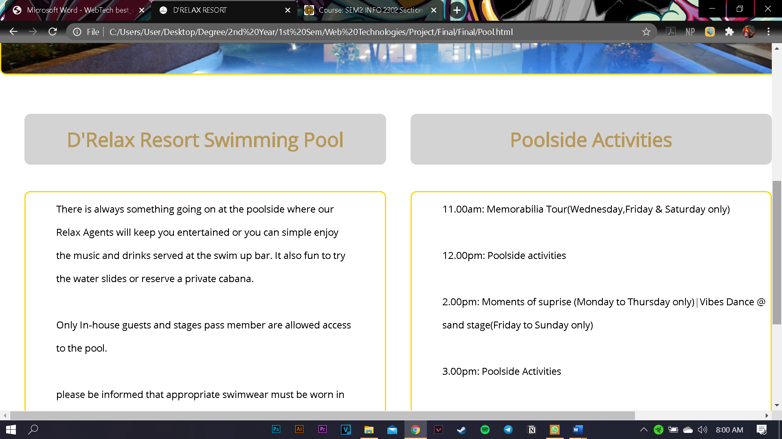

Figure 6 Swimming Pool Page

* Details are added in the field by using Atom

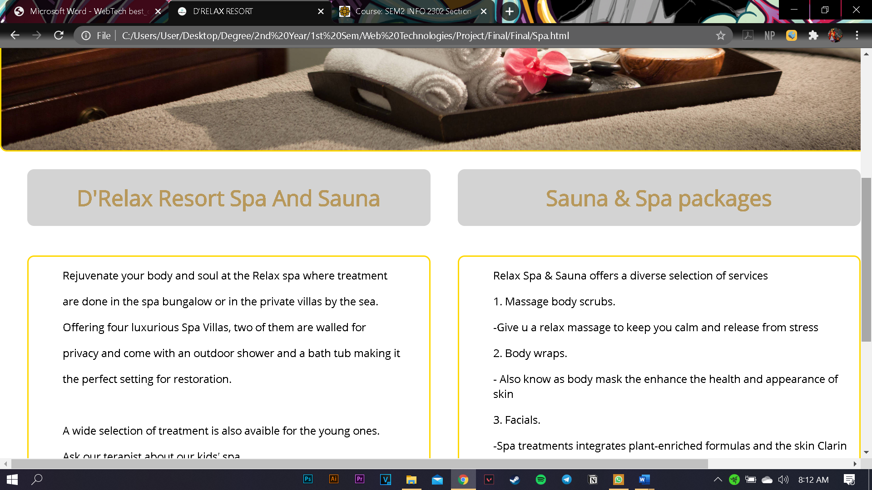

Figure 7 Spa and Sauna Page

* Layout, text and alignment are used to make text read clearly

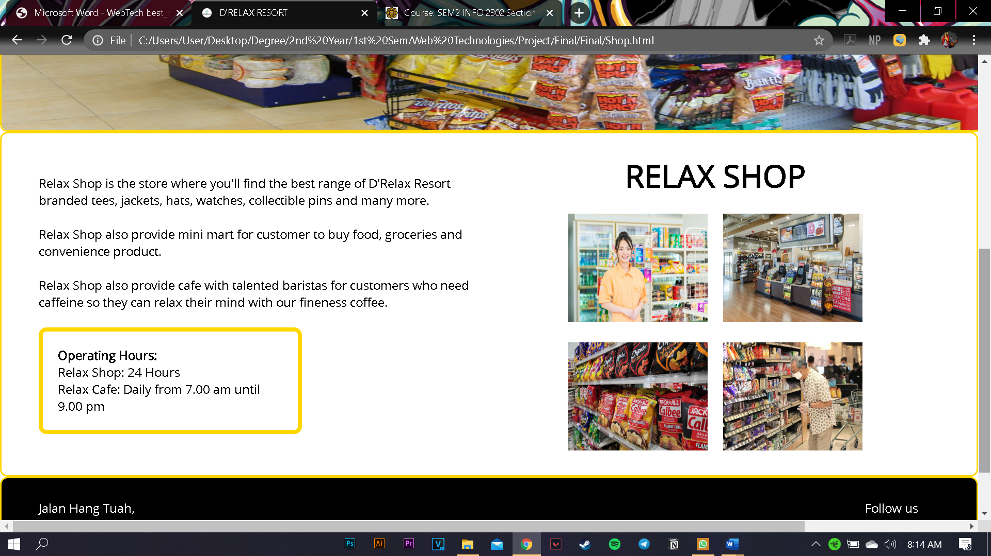

Figure 8 Store Page

* Detail of Shop page are hidden in the css page.

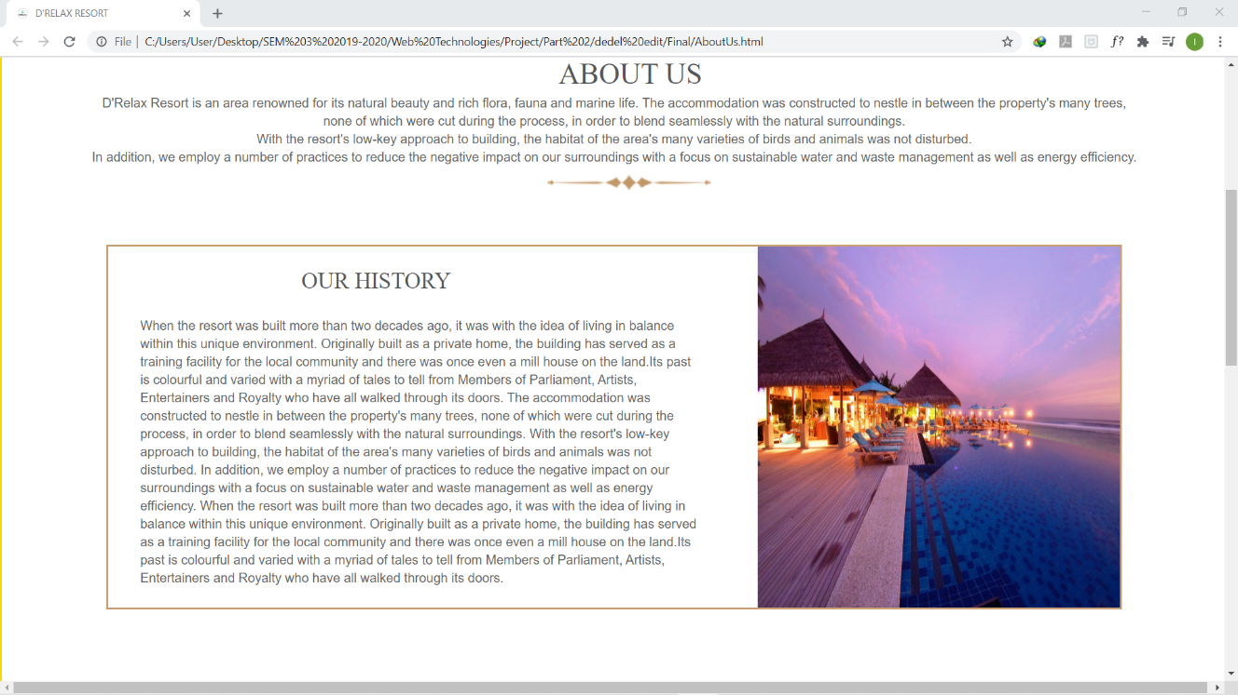

Figure 9 About Us Page

* The active accordion panel is enhanced

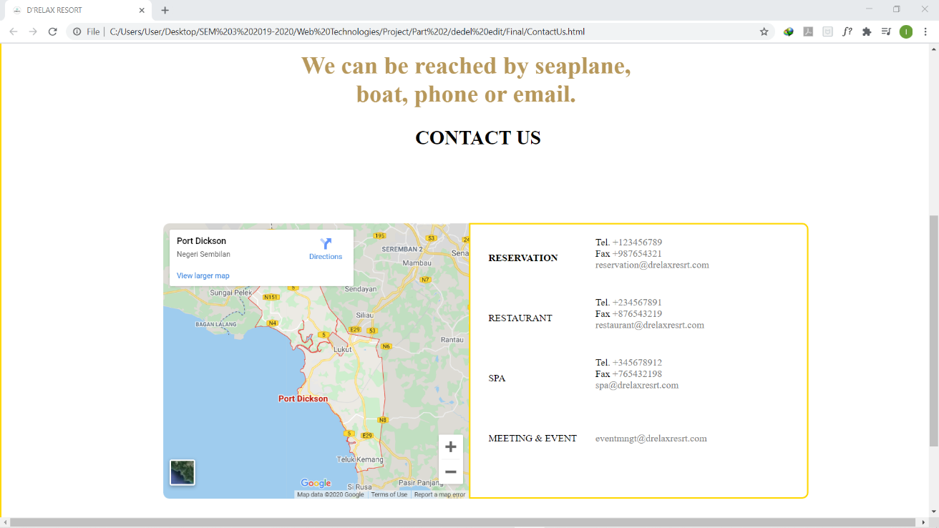

Figure 10 Contact Us Page

* Information are complete, interesting and given proper credits ( in the Readme file)